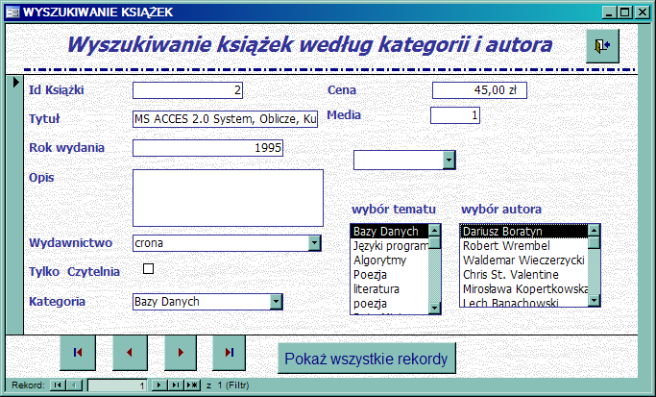

Private Sub combo1_AfterUpdate()
DoCmd.ApplyFilter , " [id_kategorii] =" & Me!combo1.Value
End Sub

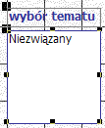

Private Sub combo2_AfterUpdate()
DoCmd.ApplyFilter , "[Id Ksiazki] In (SELECT AUTOR_KSIAZKI.[Id Ksiazki]FROM AUTOR_KSIAZKI WHERE (((AUTOR_KSIAZKI.[Id Autora])=" & Me!combo2.Value & ")))"
End Sub

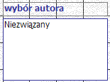
Private Sub Combo38_AfterUpdate()
DoCmd.ApplyFilter , " [id_kategorii] =" & Me!Combo38.Value
End Sub

Private Sub Polecenie36_Click()
DoCmd.ShowAllRecords
End Sub

